Philadelphia University
Faculty of Information Technology
Department of Software Engineering

Lecturer: Mr. A. Obidat
Coordinator: Mr. A. Obidat
Internal Examiner: Dr. A. Fuad

Object Oriented Data Structure (721221) First Semester 2012-13 sec 2
Exam Date: 11/11/2012 Time: 50 minutes

Student Name: Student #:

Information for Candidates
1. This examination paper contains 5 questions on 3 pages totaling (25) marks.
- The marks of questions are shown in round brackets. (-- marks).
Advice to Candidates
1- You should attempt all questions.
2- You should write your answers clearly.

I. Basic Notions
Objectives: The aim of the questions in this part is to evaluate the required minimal student knowledge and skills. Answers in the pass category represent the minimum acceptable standard.

Question 1: Choose the correct answer among the alternatives: (6 marks)

1) A data type whose elements are single is:
A) Composite type
B) Atomic or primitive type
C) Structured composite type
D) Complex type

2) Which of the following is an example of composite structured data type?
A) int
B) class
C) array
D) float

3) Which of the following is true about interfaces?
A) All variables declared in an interface must be final and static variables.
B) only one method declared in an interface must be abstract.
C) A+B
D) None of the above

4) Interfaces can be used in the following ways:
A) As a contract
B) To share constants
C) To replace multiple inheritance
D) All the above
II. Familiar Problems Solving
Objectives: The aim of the questions in this part is to evaluate that have some basic knowledge of the key aspects of the lecture material and can attempt to solve familiar problems.

Question 2 : In unsortedStringList class if item1, currPos and list have the (6 marks)
following initial values: Item1 = “sami”, currPos = 1 List:
“Ali”
“Zain”
A) Determine the values of if item1,
currPos and list after execution the
following: [3 marks]

insert(item1)
item1 = getNextItem();
delete(item1)
reset()
item1 = getNextItem()
insert(item1)

B) Repeat part a using SortedStringList class and with the same initial values for item1, currPos and list.[3 marks]

Sol:

List:
“Ali”
“sami”
“Ali”
A) Item1 = “Ali”, currPos = 1

B) Item1 = “Ali”, currPos = 1
List:
“Ali”
“Ali”
“Zain”

Question 3 : apply Binary search algorithm for the following list to find the item (cat) and then fill the following table with all the values that first, midPoint and last variables will take in each iteration. (4.5 marks)
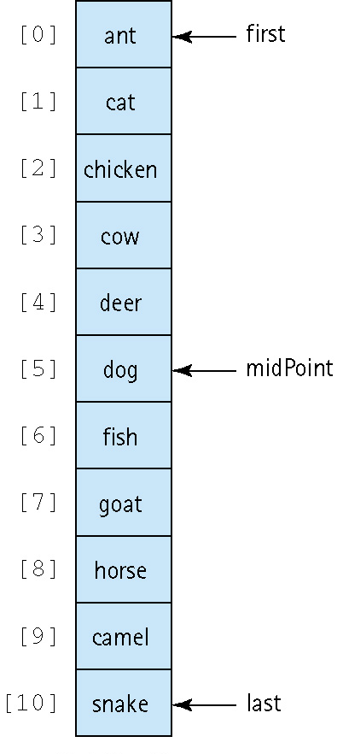
iteration | first | midPoint | last
initially | 0 | 5 | 10

Sol:
iteration | first | midPoint | last
initially | 0 | 5 | 10
 | 0 | 2 | 4
 | 0 | 0 | 1
 | 1 | 1 | 1

Question 4: Describe the order of magnitude of each of the following functions using Big-O notation : (3 marks)
a) N ⁵+ N³ + 22 [1 mark]
b) x = 0;
for (i = 1; i <= N; i++)
for (j = 1; j <= N; j++)
x=2; [1 mark]

Sol:
a) O( N ⁵)
b) O( N ²)

III. Unfamiliar Problems Solving
Objectives: The aim of the questions in this part is to evaluate that you can make progress towards the solution of unfamiliar problems.

Question 5: The Unsorted List ADT (for UnsortedStringList) is to be extended with an operation, doubleInsert , which insert two new items (item1, item2) after each call instead of only one item.. (5.5 marks)

Sol:
Public void doubleInsert(String item1, String item2)
{
list[numItems] = new String(item1);
numItems++;
list[numItems] = new String(item2);
numItems++;
}

